**Model First**

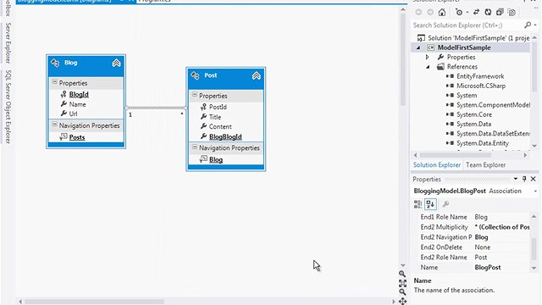

Up Next

0

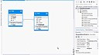

Entity Framework Model First

Entity Framework Model First

Share

**Entity Framework Model First**

Entity Framework Model First

Date 8/3/12, Duration 8:02, Views 36699

Video by:  [MSDN Product Group](http://www.bing.com/videos/browse/source?tag=altenus_msdn%3aaltenus_msdn_pg)

**Pre-Requisites**

You will need to have Visual Studio 2010 or Visual Studio 2012 installed to complete this walkthrough.

If you are using Visual Studio 2010, you will also need to have [NuGet](http://visualstudiogallery.msdn.microsoft.com/27077b70-9dad-4c64-adcf-c7cf6bc9970c) installed.

**1. Create the Application**

To keep things simple we’re going to build a basic console application that uses the Model First to perform data access:

* Open Visual Studio
* **File -> New -> Project…**
* Select **Windows** from the left menu and **Console Application**
* Enter **ModelFirstSample** as the name
* Select **OK**

**2. Create Model**

We’re going to make use of Entity Framework Designer, which is included as part of Visual Studio, to create our model.

* **Project -> Add New Item…**
* Select **Data** from the left menu and then **ADO.NET Entity Data Model**
* Enter **BloggingModel** as the name and click **OK**, this launches the Entity Data Model Wizard
* Select **Empty Model** and click **Finish**  
  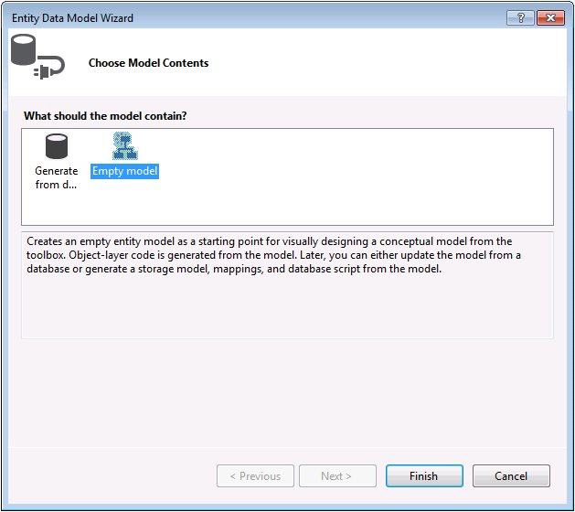

The Entity Framework Designer is opened with a blank model. Now we can start adding entities, properties and associations to the model.

* Right-click on the design surface and select **Properties**
* In the Properties window change the **Entity Container Name** to **BloggingContext**  
  *This is the name of the derived context that will be generated for you, the context represents a session with the database, allowing us to query and save data*
* Right-click on the design surface and select **Add New -> Entity…**
* Enter **Blog** as the entity name and **BlogId** as the key name and click **OK**  
  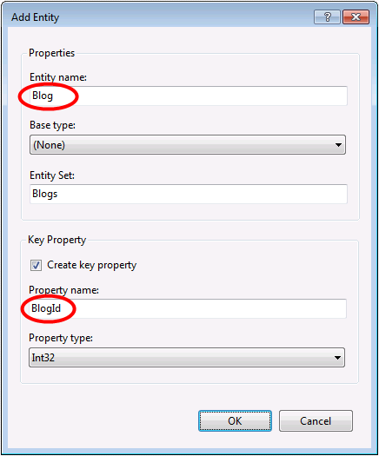
* Right-click on the new entity on the design surface and select **Add New -> Scalar Property**, enter **Name** as the name of the property.
* Repeat this process to add a **Url** property.
* Right-click on the **Url** property on the design surface and select **Properties**, in the Properties window change the **Nullable** setting to **True**  
  *This allows us to save a Blog to the database without assigning it a Url*
* Using the techniques you just learnt, add a **Post** entity with a **PostId** key property
* Add **Title** and **Content** scalar properties to the **Post** entity

Now that we have a couple of entities, it’s time to add an association (or relationship) between them.

* Right-click on the design surface and select **Add New -> Association…**
* Make one end of the relationship point to **Blog** with a multiplicity of **One** and the other end point to **Post** with a multiplicity of **Many**  
  *This means that a Blog has many Posts and a Post belongs to one Blog*
* Ensure the **Add foreign key properties to 'Post' Entity** box is checked and click **OK**  
  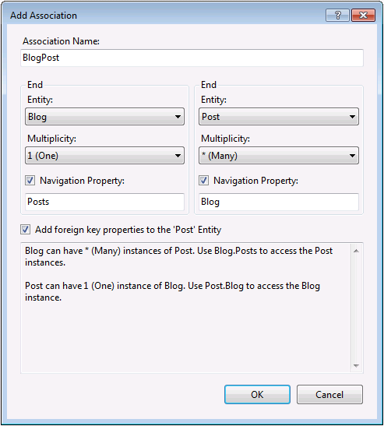

We now have a simple model that we can generate a database from and use to read and write data.  
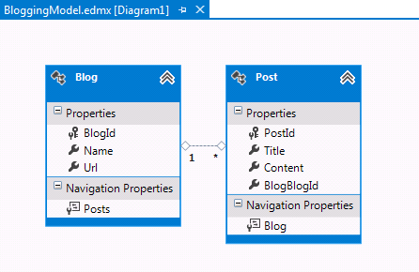

**Additional Steps in Visual Studio 2010**

If you are working in Visual Studio 2010 there are some additional steps you need to follow to upgrade to the latest version of Entity Framework. Upgrading is important because it gives you access to an improved API surface, that is much easier to use, as well as the latest bug fixes.

First up, we need to get the latest version of Entity Framework from NuGet.

* **Project –> Manage NuGet Packages…**  
  *If you don’t have the* ***Manage NuGet Packages…*** *option you should install the* [*latest version of NuGet*](http://visualstudiogallery.msdn.microsoft.com/27077b70-9dad-4c64-adcf-c7cf6bc9970c)
* Select the **Online** tab
* Select the **EntityFramework** package
* Click **Install**

Next, we need to swap our model to generate code that makes use of the DbContext API, which was introduced in later versions of Entity Framework.

* Right-click on an empty spot of your model in the EF Designer and select **Add Code Generation Item…**
* Select **Online Templates** from the left menu and search for **DbContext**
* Select the EF **5.x DbContext Generator for C#**, enter **BloggingModel** as the name and click **Add**  
  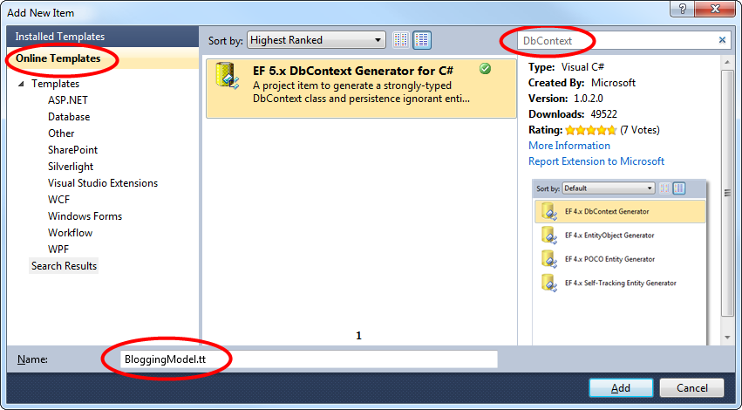

**3. Generating the Database**

Given our model, Entity Framework can calculate a database schema that will allow us to store and retrieve data using the model.

The database server that is installed with Visual Studio is different depending on the version of Visual Studio you have installed:

* If you are using Visual Studio 2010 you'll be creating a SQL Express database.
* If you are using Visual Studio 2012 then you'll be creating a [LocalDb](http://msdn.microsoft.com/en-us/library/hh510202(v=SQL.110).aspx) database.

Let's go ahead and generate the database.

* Right-click on the design surface and select **Generate Database from Model…**
* Click **New Connection…** and specify either LocalDb (**(localdb)\v11.0**) or SQL Express (**.\SQLEXPRESS**), depending on which version of Visual Studio you are using, enter **ModelFirst.Blogging** as the database name.  
  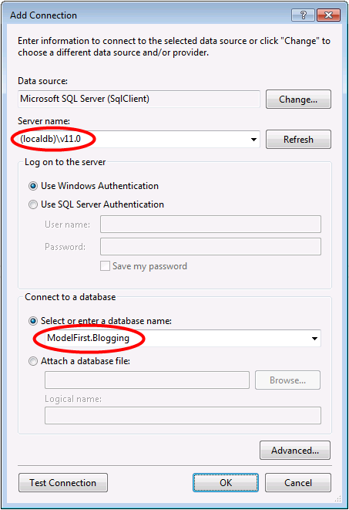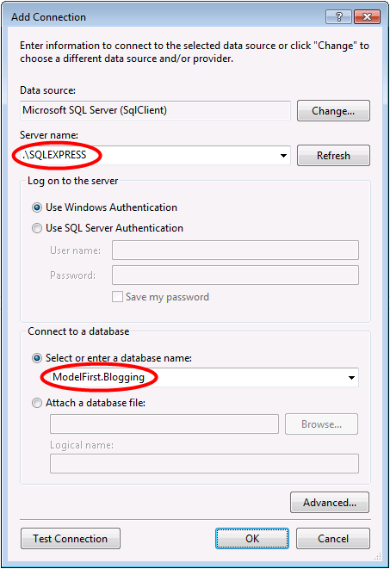
* Select **OK** and you will be asked if you want to create a new database, select **Yes**
* Select **Next** and the Entity Framework Designer will calculate a script to create the database schema
* Once the script is displayed, click **Finish** and the script will be added to your project and opened
* Right-click on the script and select **Execute**, you will be prompted to specify the database to connect to, specify **(localdb)\v11.0** or**.\SQLEXPRESS**, depending on which version of Visual Studio you are using

**4. Reading & Writing Data**

Now that we have a model it’s time to use it to access some data. The classes we are going to use to access data are being automatically generated for you based on the EDMX file.

*This screen shot is from Visual Studio 2012, if you are using Visual Studio 2010 the BloggingModel.tt and BloggingModel.Context.tt files will be directly under your project rather than nested under the EDMX file.*

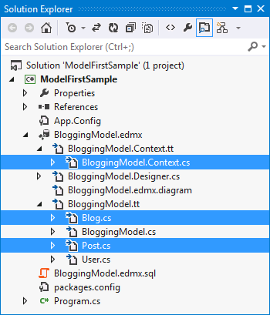

Implement the Main method in Program.cs as shown below. This code creates a new instance of our context and then uses it to insert a new Blog. Then it uses a LINQ query to retrieve all Blogs from the database ordered alphabetically by Title.

**class** Program   
{   
    **static** **void** Main(**string**[] args)   
    {   
        **using** (var db = **new** BloggingContext())   
        {   
            // Create and save a new Blog   
            Console.Write("Enter a name for a new Blog: ");   
            var name = Console.ReadLine();   
   
            var blog = **new** Blog { Name = name };   
            db.Blogs.Add(blog);   
            db.SaveChanges();   
   
            // Display all Blogs from the database   
            var query = from b **in** db.Blogs   
                        orderby b.Name   
                        select b;   
   
            Console.WriteLine("All blogs in the database:");   
            **foreach** (var item **in** query)   
            {   
                Console.WriteLine(item.Name);   
            }   
   
            Console.WriteLine("Press any key to exit...");   
            Console.ReadKey();   
        }   
    }   
}

You can now run the application and test it out.

|  |
| --- |
| Enter a name for a new Blog: *ADO.NET Blog* All blogs in the database: ADO.NET Blog Press any key to exit... |

**5. Dealing with Model Changes**

Now it’s time to make some changes to our model, when we make these changes we also need to update the database schema.

We’ll start by adding a new User entity to our model.

* Add a new **User** entity name with **Username** as the key name and **String** as the property type for the key  
  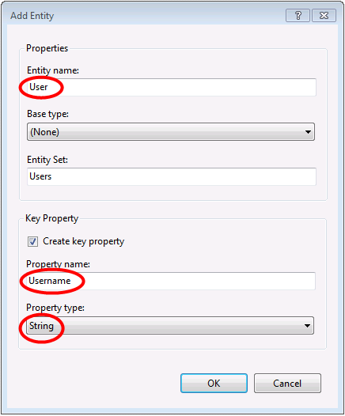
* Right-click on the **Username** property on the design surface and select **Properties**, In the Properties window change the **MaxLength** setting to **50**  
  *This restricts the data that can be stored in username to 50 characters*
* Add a **DisplayName** scalar property to the **User** entity

We now have an updated model and we are ready to update the database to accommodate our new User entity type.

* Right-click on the design surface and select **Generate Database from Model…**, Entity Framework will calculate a script to recreate a schema based on the updated model.
* Click **Finish**
* You may receive warnings about overwriting the existing DDL script and the mapping and storage parts of the model, click **Yes** for both these warnings
* The updated SQL script to create the database is opened for you  
  *The script that is generated will drop all existing tables and then recreate the schema from scratch. This may work for local development but is not a viable for pushing changes to a database that has already been deployed. If you need to publish changes to a database that has already been deployed, you will need to edit the script or use a schema compare tool to calculate a migration script.*
* Right-click on the script and select **Execute**, you will be prompted to specify the database to connect to, specify **(localdb)\v11.0** or**.\SQLEXPRESS**, depending on which version of Visual Studio you are using

**Summary**

In this walkthrough we looked at Model First development, which allowed us to create a model in the EF Designer and then generate a database from that model. We then used the model to read and write some data from the database. Finally, we updated the model and then recreated the database schema to match the model.